**Lab 2: Rectifier Circuits (2% of total)**

**Objective:**

To assemble and test several rectifier circuits.

**Equipment and Components:**

* Breadboard, Function generator, Oscilloscope
* Diodes (1N4003)
* Op-amp (LM348N)
* Resistors (100Ω, 1kΩ, 10kΩ)
* Capacitors (47uF)

**Pre-Lab:**

The configuration shown in Fig. 2.3 is known as superdiode.Simulate the circuit using LM348N op-amp. For opamp power supplies, use V+ = 15 V, V- = -15V. Find the datasheet for the op-amp and use it to determine the pin connections.

**Procedure:**

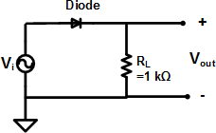 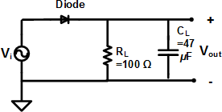

Fig. 2.1 Half-wave rectifier Fig. 2.2 Peak rectifier

= 10kΩ

Superdiode

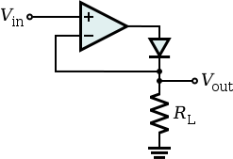

**Super diode**

Fig. 2.3 Precision Half-Wave Rectifier (Superdiode rectifier)

**Part 1:**

1. Build the Half-wave rectifier circuit on the breadboard.
2. Using the function generator, provide a sinusoidal input of 10Vpk-pk and 1kHz.
3. Using the oscilloscope, capture the input and output waveforms.
4. Record the peak voltage value for Vout and label it as Vp.

**Part 2:**

1. Using the same input source as Part 1, build the following:
   1. Peak detector I: Use **RL**  = 1 kΩ, **CL** = 47 *μ*F.
   2. Peak Detector II: Use **RL**  = 100 Ω, **CL** = 47 *μ*F
2. For both the circuits, record the plot for Vin and Vout. Record the peak voltage (Vp), ripple voltage (VR), and DC voltage (VDC).

**Part 3:**

1. Using the same input source as Part 1, build the precision half-wave rectifier circuit.
2. Record the oscilloscope plots for Vin and Vout vs. time.
3. Record the peak output voltage (Vp).
4. Using the X-Y mode on the oscilloscope, plot Vout vs. Vin.
5. How does the rectifier work for input voltage amplitude less than the diode voltage drop?

**Conclusion:**

1. Compare the measured values with the simulation results from Lab 1 & 2 calculated results in a tabular form. *Get your summary table checked off by the instructor.*